Gradient Descent: A Comprehensive Guide
Mathematical Foundations and Optimization Algorithms
An in-depth exploration of gradient descent algorithms, covering mathematical principles, derivatives, various optimization methods, and practical applications in machine learning.
Autor: Generated by Claude Haiku 4.5
February 2026

Introduction to Gradient Descent
Gradient descent is one of the most fundamental optimization algorithms in machine learning and deep learning. It is an iterative method used to find the minimum of a function by moving in the direction of the steepest descent, which is determined by the negative of the gradient. This algorithm forms the backbone of training neural networks and fitting machine learning models to data.The core idea is elegantly simple: start with random parameters, compute the gradient of the loss function with respect to these parameters, and update the parameters by taking small steps in the opposite direction of the gradient. By repeating this process, the algorithm gradually converges toward a minimum, where the model's performance is optimized.Understanding gradient descent requires a solid grasp of calculus, particularly derivatives and partial derivatives. These mathematical concepts provide the foundation for understanding how the algorithm navigates the parameter space and converges to optimal solutions.

Mathematical Foundations

Understanding Derivatives
A derivative measures the rate of change of a function at a specific point. Formally, the derivative of a function f(x) at a point x is defined as the limit of the difference quotient as the change in x approaches zero. This concept is visualized as the slope of the tangent line to the function at that point.The derivative formula is expressed as: df/dx = lim(Δx→0) [f(x+Δx) - f(x)] / Δx. This represents the instantaneous rate of change of the function. In the context of optimization, derivatives tell us the direction and magnitude of the steepest ascent or descent of a function.
$\frac{df}{dx}=\lim_{Δx→0}\frac{f(x+Δx)−f(x)}{Δx}$
Equation 1: Definition of the Derivative
For functions with multiple variables, we use partial derivatives. Each partial derivative represents the rate of change with respect to one variable while holding others constant. The collection of all partial derivatives forms the gradient vector, which points in the direction of steepest increase.
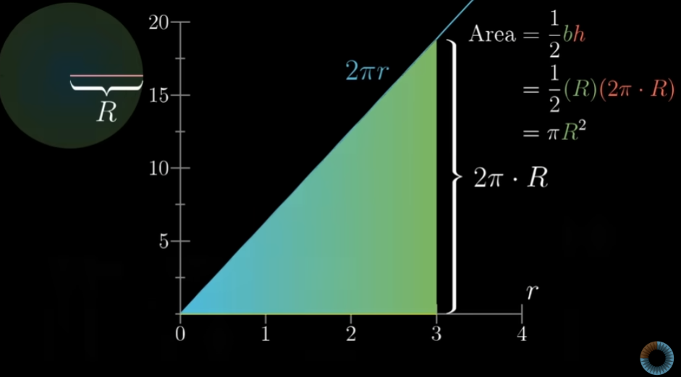
Fig. 13: Area and Integration - Fundamental calculus concepts underlying optimization
The first derivative test is crucial for identifying critical points. When the derivative equals zero, the function has a critical point, which could be a local minimum, local maximum, or saddle point. The second derivative test helps distinguish between these cases.
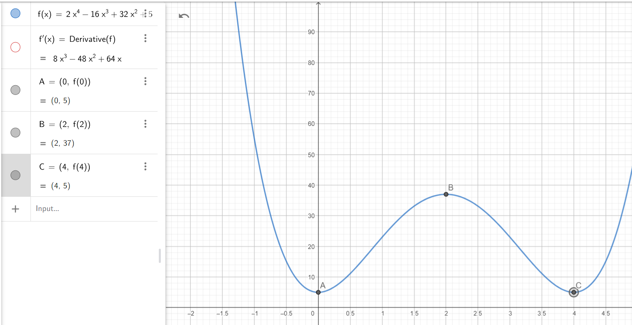
Fig. 12: First Derivative Test - Critical points and function behavior analysis
In optimization, we are interested in finding where the derivative is zero, as these points represent potential minima or maxima. For gradient descent, we move in the direction opposite to the gradient to reach lower values of the cost function.
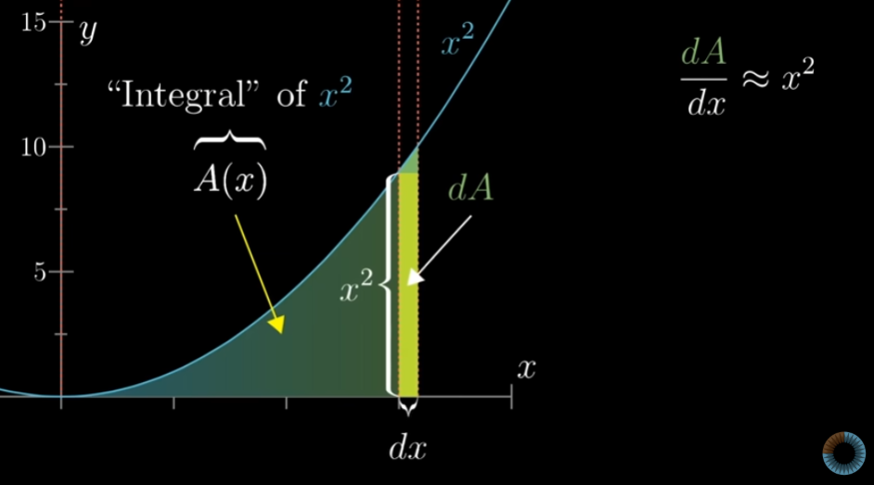
Fig. 2: Derivative Concept - The slope of the tangent line represents the rate of change

The Gradient Concept
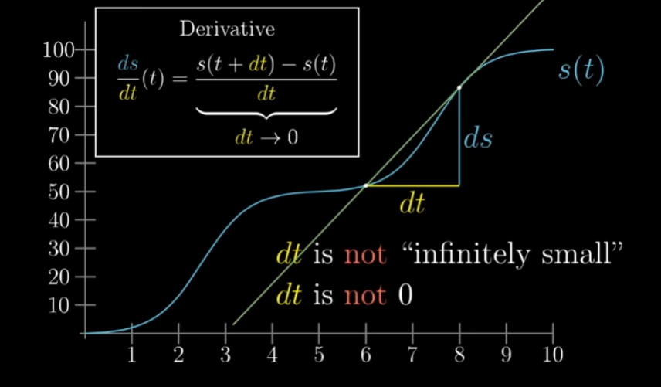
Fig. 3: Second Derivative and Concavity - Understanding function behavior
The gradient is a vector that contains all the partial derivatives of a multivariate function. For a function f(x₁, x₂, ..., xₙ), the gradient ∇f is defined as the vector [∂f/∂x₁, ∂f/∂x₂, ..., ∂f/∂xₙ]. The gradient always points in the direction of the steepest increase of the function.
$∇f=\left[\frac{∂f}{∂x_{1}},\frac{∂f}{∂x_{2}},…,\frac{∂f}{∂x_{n}}\right]$
Equation 2: Gradient Vector Definition
In the context of machine learning, the gradient represents how much the loss function will change with respect to small changes in each parameter. By computing the gradient, we determine the optimal direction to adjust our parameters to reduce the loss.
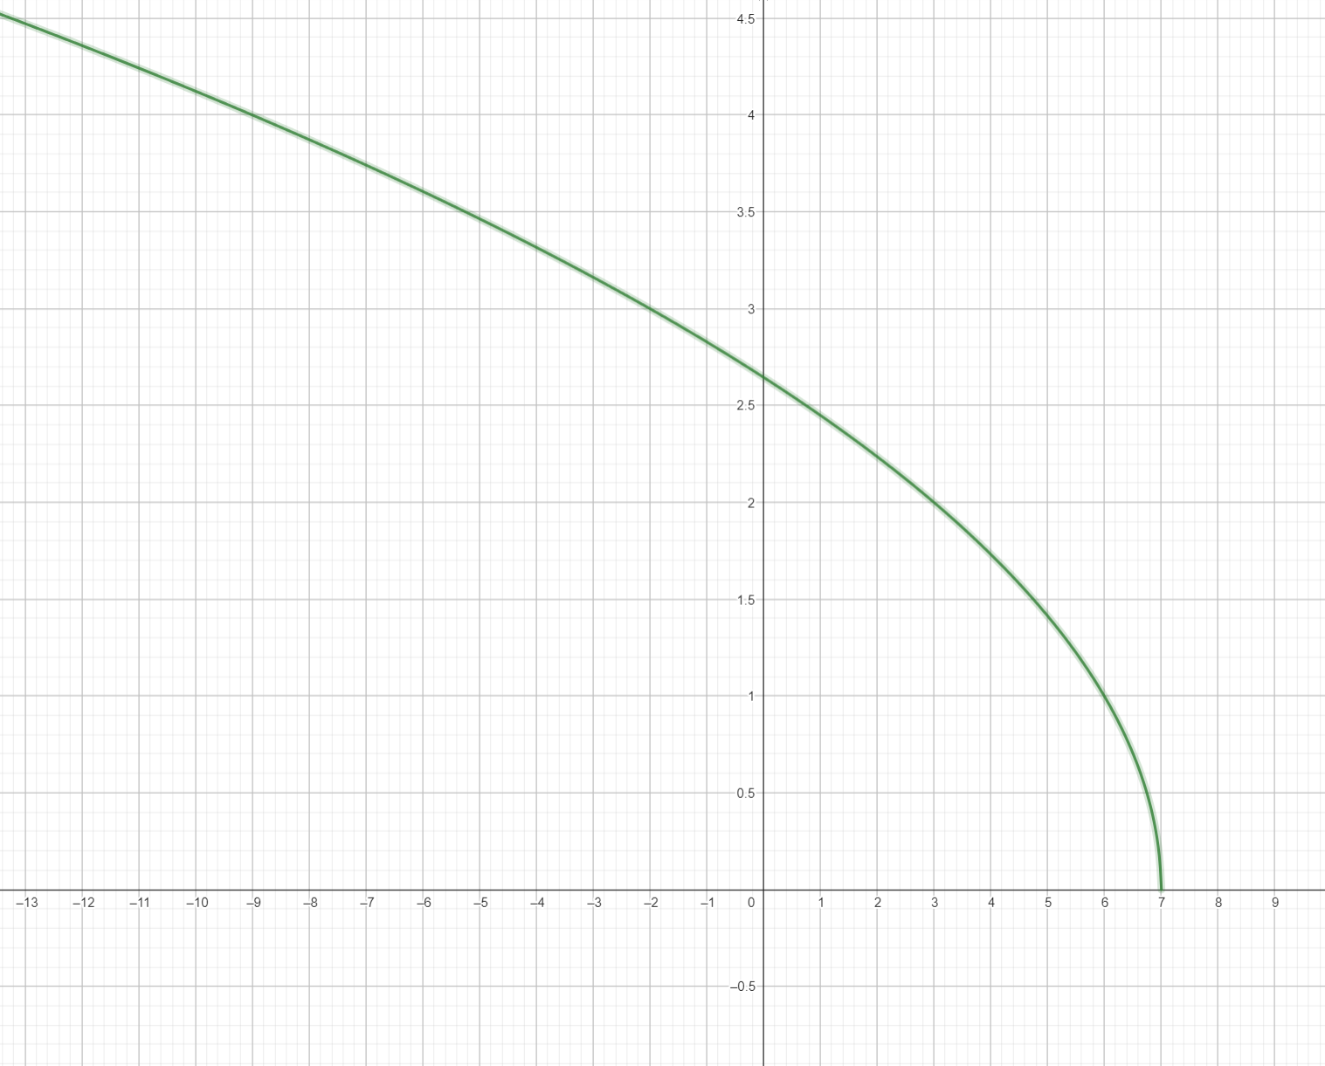
Fig. 5: Domain and Function Mapping - Understanding function spaces
The gradient descent update rule is expressed as: θ_new = θ_old - α∇J(θ), where θ represents the parameters, α is the learning rate, and ∇J(θ) is the gradient of the cost function. The negative sign ensures we move opposite to the gradient, toward lower cost values.
$θ_{new}=θ_{old}−α∇J(θ)$
Equation 3: Gradient Descent Update Rule
The learning rate α is a hyperparameter that controls the size of each step. A small learning rate leads to slow convergence, while a large learning rate may cause the algorithm to overshoot the minimum or diverge. Finding the optimal learning rate is crucial for effective optimization.Visualizing gradient descent in parameter space reveals how the algorithm navigates through the landscape of the cost function. The contour plots show level sets of equal cost, and the gradient descent trajectory moves perpendicular to these contours toward the minimum.
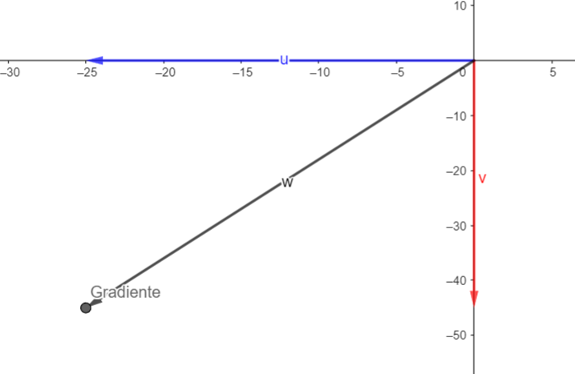
Fig. 4: Gradient Vector Visualization - Direction of steepest ascent in 2D parameter space
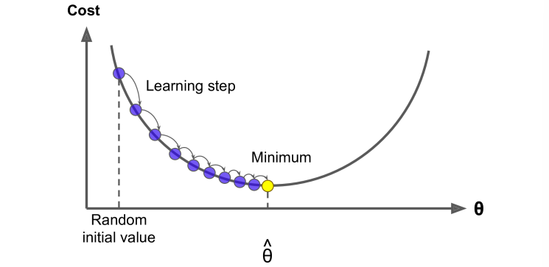
Fig. 10: Gradient Vector Field - Visualization of gradients in 2D space

Types of Gradient Descent

Batch Gradient Descent
Batch gradient descent computes the gradient using the entire training dataset. This approach provides an accurate estimate of the true gradient, leading to stable and consistent updates. However, it can be computationally expensive for large datasets.The update rule for batch gradient descent is: θ = θ - α(1/m)∑ᵢ₌₁ᵐ ∇J(θ; xⁱ, yⁱ), where m is the number of training samples. The algorithm processes all samples before making a single parameter update.
$θ=θ−α\frac{1}{m}\sum_{i=1}^{m}{∇J(θ;x^{i},y^{i})}$
Equation 4: Batch Gradient Descent Update
Advantages of batch gradient descent include smooth convergence and reliable gradient estimates. The disadvantage is that it requires storing and processing the entire dataset in memory, making it impractical for very large datasets or streaming data scenarios.Batch gradient descent typically converges to a solution, though it may get stuck in local minima. The convergence is generally smooth and monotonic, making it easier to debug and understand.
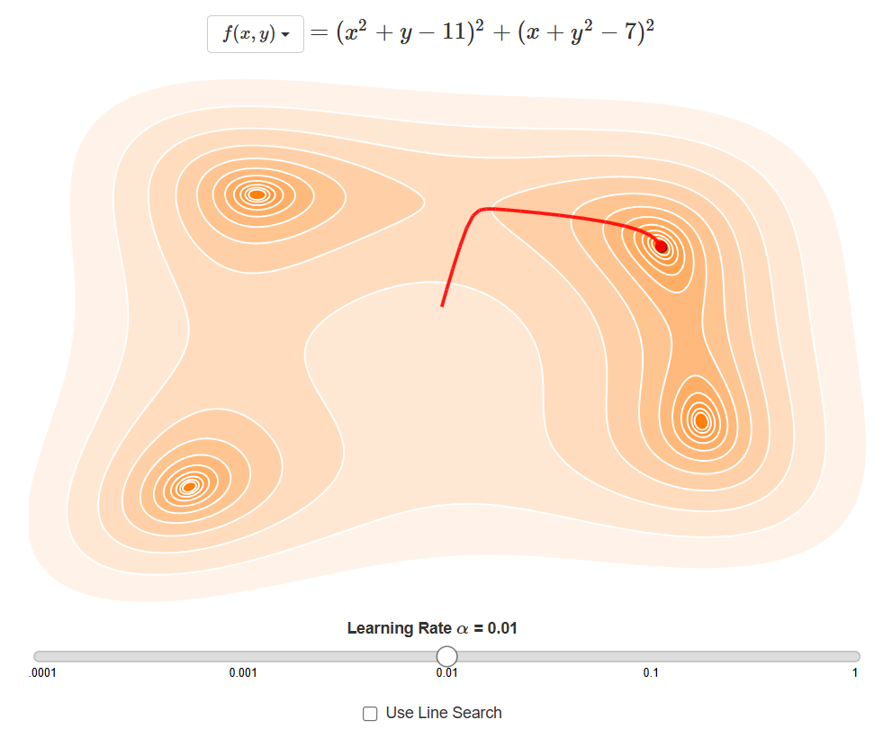
Fig. 1: Gradient Descent Optimization - Iterative steps moving toward the minimum cost
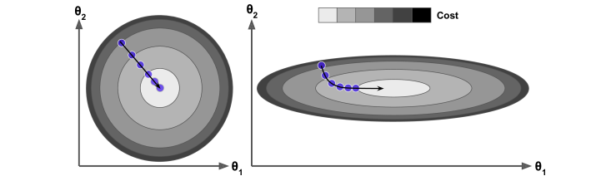
Fig. 6: Gradient Descent with Two Features - Contour plot showing convergence path

Stochastic Gradient Descent (SGD)
Stochastic gradient descent updates parameters after processing each individual sample. This introduces noise into the gradient estimates but allows for faster updates and better exploration of the parameter space.The update rule for SGD is: θ = θ - α∇J(θ; xⁱ, yⁱ), where the gradient is computed for a single sample. This noisy gradient can help escape local minima and plateaus.
$θ=θ−α∇J(θ;x^{i},y^{i})$
Equation 5: Stochastic Gradient Descent Update
SGD is particularly useful for large-scale machine learning problems and online learning scenarios. The noise in the gradient estimates, while seemingly disadvantageous, can actually help the algorithm explore the parameter space more thoroughly.The trade-off with SGD is that convergence is less stable and may oscillate around the minimum. However, this often leads to better generalization on unseen data compared to batch gradient descent.
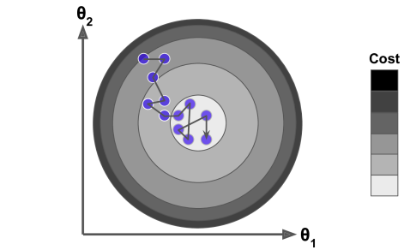
Fig. 7: Stochastic Gradient Descent - Noisy but faster convergence path

Mini-Batch Gradient Descent
Mini-batch gradient descent represents a compromise between batch and stochastic approaches. It computes gradients on small batches of samples, typically ranging from 32 to 256 samples, balancing computational efficiency with gradient stability.The update rule for mini-batch GD is: θ = θ - α(1/b)∑ᵢ₌₁ᵇ ∇J(θ; xⁱ, yⁱ), where b is the batch size. This approach is the most commonly used in practice for training deep neural networks.
$θ=θ−α\frac{1}{b}\sum_{i=1}^{b}{∇J(θ;x^{i},y^{i})}$
Equation 6: Mini-Batch Gradient Descent Update
Mini-batch gradient descent provides a good balance between computational efficiency and convergence stability. It allows for vectorized operations on modern hardware, making it significantly faster than processing samples one at a time.
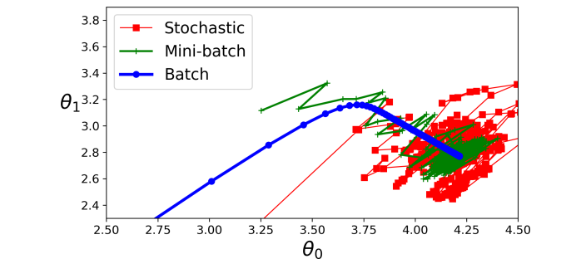
Fig. 8: Comparison of GD Variants - Batch, Stochastic, and Mini-batch trajectories

Challenges and Pitfalls

Learning Rate and Convergence
One of the primary challenges in gradient descent is selecting an appropriate learning rate. Too small a learning rate results in very slow convergence, while too large a learning rate can cause divergence or oscillation around the minimum.Learning rate scheduling techniques adjust the learning rate during training. Common strategies include exponential decay, step decay, and adaptive methods like Adam and RMSprop, which adjust the learning rate based on the history of gradients.
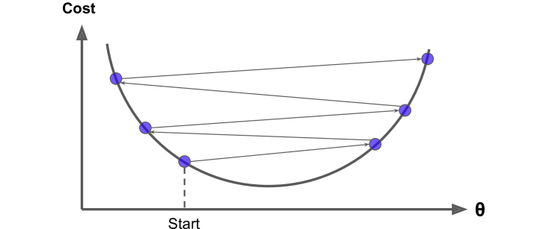
Fig. 11: Big Learning Rate Effects - Demonstrating convergence with different learning rates
Convergence criteria must be carefully chosen. Common approaches include monitoring the change in loss function values, checking the magnitude of gradient updates, or setting a maximum number of iterations.Early stopping is a practical technique that monitors validation performance and stops training when performance plateaus, preventing overfitting and saving computational resources.
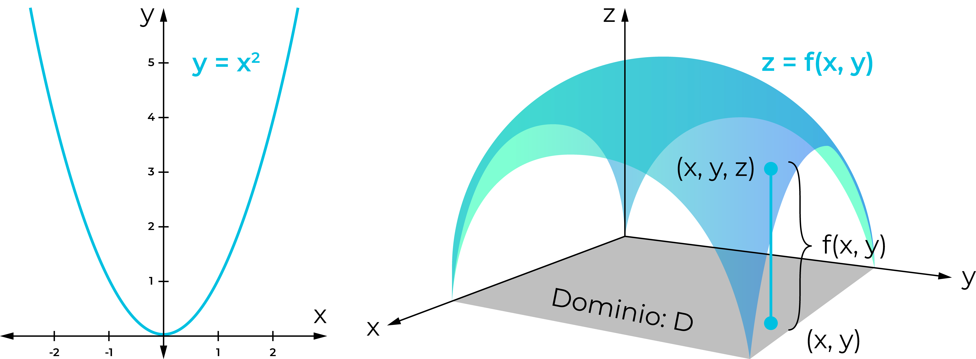
Fig. 14: Complex Function Landscape - Contour plot with multiple minima and learning rate effects

Local Minima and Plateaus
Gradient descent can converge to local minima rather than the global minimum, especially in non-convex optimization problems common in deep learning. Local minima represent suboptimal solutions where the gradient is zero but the function value is not globally minimal.Plateaus are regions where the gradient is very small, causing the algorithm to progress slowly. These flat regions can occur in high-dimensional spaces and may be mistaken for convergence when in fact the algorithm is simply moving very slowly.Saddle points are critical points where the gradient is zero but the point is neither a local minimum nor maximum. In high dimensions, saddle points are more common than local minima, and gradient descent can get stuck at these points.
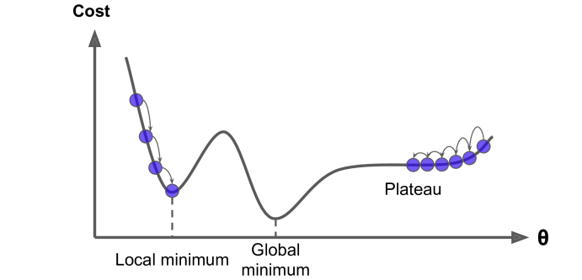
Fig. 9: Gradient Descent Pitfalls - Local minima, plateaus, and saddle points

Practical Implementation

Algorithm Comparison
Implementing gradient descent requires careful consideration of numerical stability, computational efficiency, and convergence monitoring. Modern deep learning frameworks provide automatic differentiation tools that compute gradients efficiently.The choice between batch, stochastic, and mini-batch gradient descent depends on the problem characteristics. Batch GD is best for small datasets and convex problems. SGD excels with large datasets and online learning. Mini-batch GD is the practical choice for most deep learning applications.
Table 1: Comparison of Gradient Descent Variants
Aspect | Batch GD | Stochastic GD | Mini-Batch GD
Data per Update | Entire dataset (m samples) | Single sample (1) | Batch size (b samples)
Computational Cost | High per iteration | Low per iteration | Medium per iteration
Gradient Accuracy | High (true gradient) | Low (noisy) | Medium (balanced)
Convergence Speed | Slow but stable | Fast but noisy | Fast and stable
Memory Requirements | Very high | Very low | Medium
Parallelization | Difficult | Not applicable | Excellent
Best Use Case | Small datasets | Large datasets/online | Deep learning (standard)
Generalization | May overfit | Better generalization | Good generalization
Table 2: Common Gradient Descent Challenges and Solutions
Challenge | Description | Solution
Learning Rate Too Small | Convergence is very slow | Increase learning rate or use learning rate scheduling
Learning Rate Too Large | Divergence or oscillation | Decrease learning rate or use adaptive methods
Local Minima | Algorithm stuck at suboptimal point | Use momentum, multiple random initializations
Plateaus | Gradient very small, slow progress | Use adaptive learning rates (Adam, RMSprop)
Saddle Points | Zero gradient but not minimum | Add noise (SGD) or use second-order methods
Vanishing Gradients | Gradients become very small | Use batch normalization, ReLU activations
Exploding Gradients | Gradients become very large | Gradient clipping, weight normalization

Conclusion
Gradient descent remains the foundation of modern machine learning optimization. Understanding its principles, variants, and challenges is essential for practitioners developing and training machine learning models effectively.

